Project Design Phase-II
Data Flow Diagram & User Stories
Date | 29 September 2026
Team ID | SWTID-2026-2597
Project Name | Streamlining IT Procurement
Maximum Marks | 4 Marks
Data Flow Diagram:
The DFD represents how information moves between the requester, Service Catalog, approval, Flow Designer, Requested Item and Hardware team.
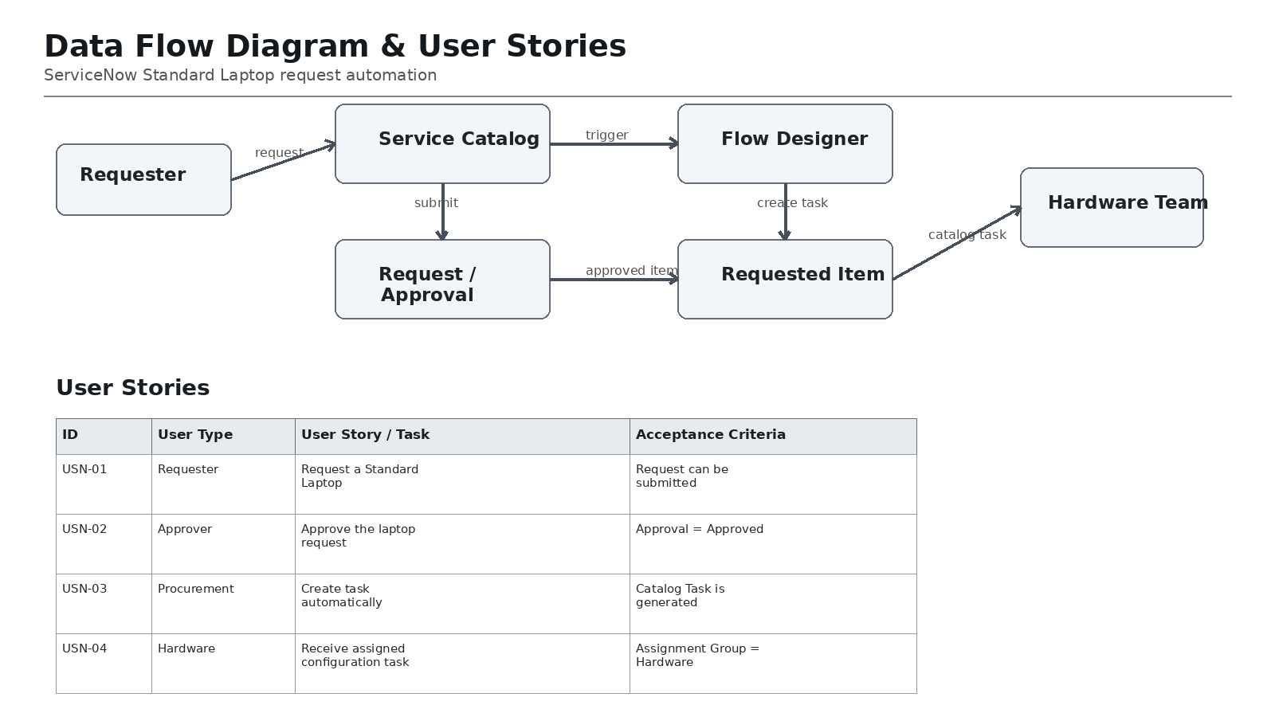
User Stories:
User Type | Epic / Functional Requirement | User Story / Task | Acceptance Criteria | Priority | Release
Requester | Standard Laptop Request | As a user, I want to request a Standard Laptop through Service Catalog. | Request can be submitted. | High | Sprint-1
Approver | Request Approval | As an approver, I want to approve the laptop request. | Approval is Approved. | High | Sprint-1
Procurement | Automation | As procurement, I want a task created automatically. | Catalog Task is generated. | High | Sprint-1
Hardware | Task Assignment | As Hardware team, I want the configuration task assigned to my group. | Assignment Group = Hardware. | High | Sprint-1
Requester | Fulfilment | As a requester, I want configuration to start without manual follow-up. | Task is created after trigger conditions. | Medium | Sprint-2

